Farmers’ Hub Planning document

EECS 2311X Team 1

Samuel Orekoya

Dexter Aromosele

Vikramjeet Singh

Jaideep Singh

Muhammed Abou-Hantash

Joseph Ajeigbe

**Vision statement**

The Farmers Hub App is poised to be a transformative force in agriculture, seamlessly connecting farmers to customers and to other farmers in a dynamic and collaborative ecosystem. Designed for both the seasoned farmer and the discerning customer, our vision is to create a platform that transcends mere transactions, fostering a sense of community, knowledge exchange, and sustainable growth.

At the core of our vision is a sophisticated yet user-friendly authentication system. By tailoring signup processes for farmers and customers, we prioritize security and personalized experiences. This ensures a seamless onboarding journey, setting the stage for a robust and interconnected agricultural network.

The heartbeat of the Farmers Hub App is its vibrant marketplace. Here, farmers showcase their produce through detailed listings, granting customers direct access to a diverse array of fresh, locally sourced products. The platform's flexibility shines through, offering customers the choice between convenient pickup or swift delivery options.

Beyond commerce, the app introduces a pioneering Reviews and Ratings system. This feature serves as a testament to our commitment to transparency and community building. Genuine feedback from customers contributes to the reliability and growth of the platform, creating a space where trust flourishes.

In a bid to further support the agricultural community, the Farmers Hub App introduces a Machinery/Tools Listings functionality. Farmers can seamlessly share, rent, or sell their equipment, transforming the platform into a vital resource-sharing hub. Each listing, complete with essential details such as equipment condition, pricing, and availability, reinforces the app's commitment to comprehensive agricultural support.

The success of the Farmers Hub App extends beyond user satisfaction metrics. We aim to streamline workflows, enhance efficiency, and contribute to cost savings. Through surveys, we anticipate users expressing a clear preference for our platform, citing superior experiences. The app's efficiency metrics will demonstrate reduced task times and increased transaction efficiency, ensuring accessibility and affordability for all users.

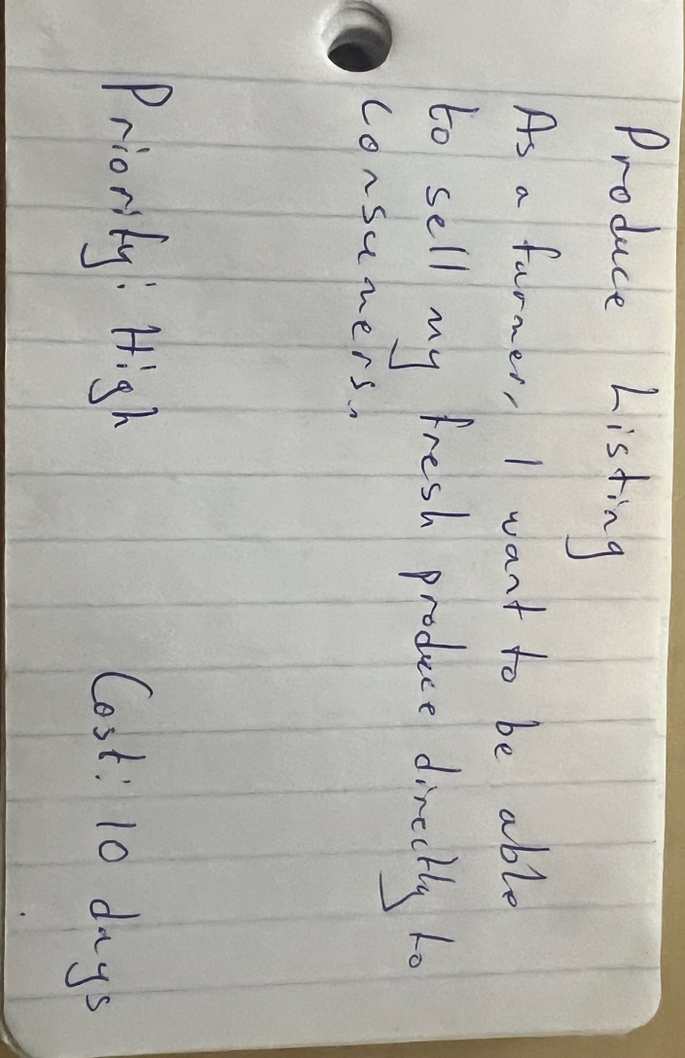In summary, the Farmers Hub App is not just an application; it's a commitment to revolutionizing agriculture. We envision a future where farmers and customers are united by a common goal: cultivating a sustainable, thriving agricultural landscape. Our platform is not merely a marketplace; it's a vibrant community hub driving the future of agriculture.

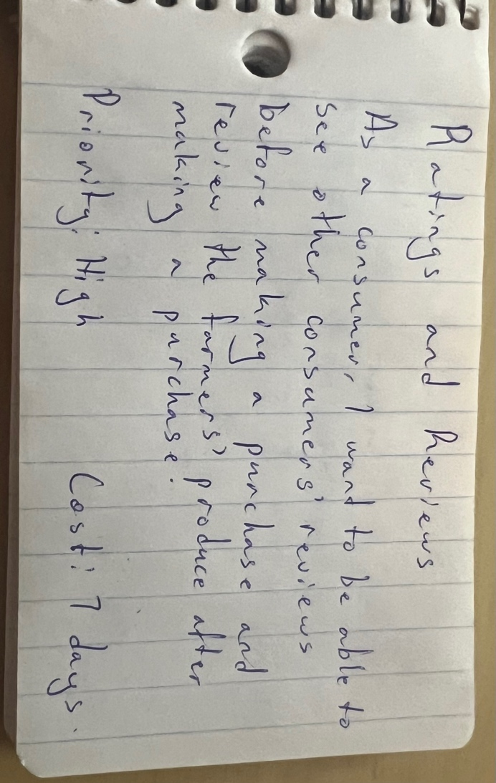**Big User stories**

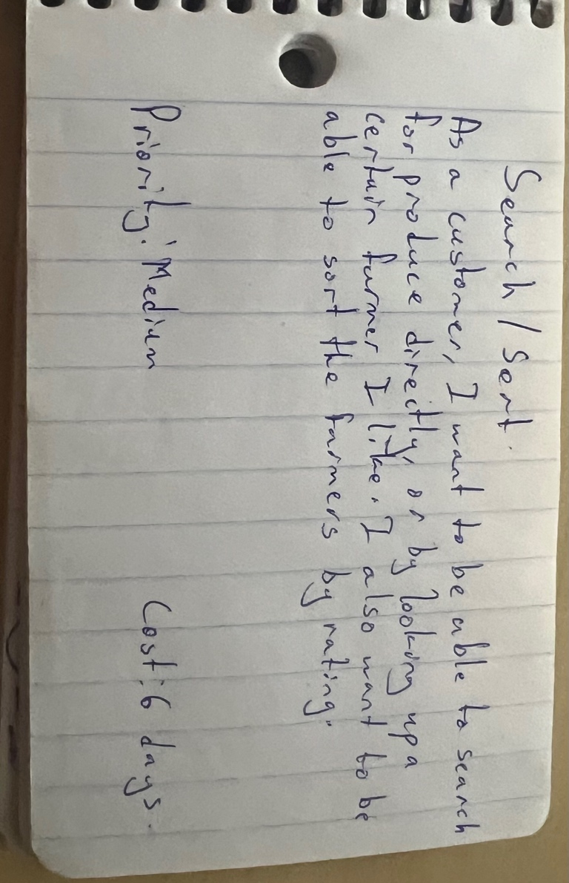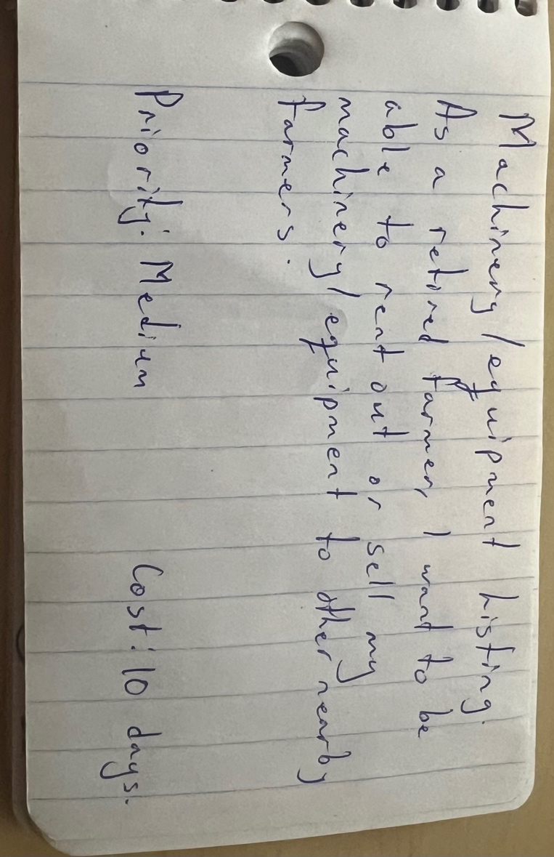

Customer meeting video link: <https://youtu.be/hRbfVbajau8?si=nd6XTemuVT_tEP2R>

**High-Level User Stories:**

1. **Farmer Landing Page**
   * Management and interaction platform for farmers.
   * Priority: High
   * Time Estimate: 13 story points
2. **Customer Landing Page**
   * Central hub for customer activities and interactions.
   * Priority: High
   * Time Estimate: 15 story points
3. **Ratings and Reviews**
   * Feedback mechanism for transactions.
   * Priority: Medium
   * Time Estimate: 8 story points
4. **Search/Sort**
   * Advanced search and sorting functionality for ease of navigation.
   * Priority: Medium
   * Time Estimate: 10 story points
5. **User Authentication**
   * Secure and robust authentication system.
   * Priority: High
   * Time Estimate: 12 story points

**Iteration Planning:**

**Iteration 1: Foundational Setup**

**Objective:** Establish basic app functionality with a focus on user authentication and initial interface setup for both farmers and customers.

* **View Login Page**: Provides users with the interface to log into their accounts. Assigned to: Vikramjeet.
* **View Produce and Machine Listings**: Allows users to browse available listings without detailed filters. Assigned to: Dexter.
* **Update a Produce/Machine Listing (Farmer Landing Page)**: Farmers can modify the details of their listings. Assigned to: Jaideep.
* **Add a New Produce/Machine Listing (Farmer Landing Page)**: Farmers can list new items for sale. Assigned to: Samuel.
* **Delete a Produce/Machine Listing (Farmer Landing Page)**: Enables farmers to remove listings from the platform. Assigned to: Joseph.

**Iteration 2: Enhanced Features**

**Objective:** Introduce key features to improve user interaction and engagement on the platform.

* **View Registration Page**: Offers a registration form for new users to create an account. Assigned to: Vikramjeet.
* **View Sales History (Farmer Landing Page)**: Farmers can view a history of their sales transactions. Assigned to: Joseph.
* **View Reviews for an Item (Customer Landing Page)**: Customers can read feedback on items before purchasing. Assigned to: Dexter.
* **Add Item to Cart (Customer Landing Page)**: Enables customers to select items for purchase. Assigned to: Samuel.
* **Increment or Decrement Item Quantity (Customer Landing Page)**: Allows customers to adjust the quantities of items in their cart. Assigned to: Jaideep.

**Iteration 3: Advanced Interactions and Data Insights**

**Objective:** Expand the app’s functionalities with advanced features for a comprehensive user experience.

* **View Order History (Customer Landing Page)**: Customers can review their past orders and statuses. Assigned to: Samuel.
* **View Shopping Cart (Customer Landing Page)**: Customers can view and modify items in their shopping cart. Assigned to: Jaideep.
* **Change Password**: Enhances account security by allowing users to update their passwords. Assigned to: Vikramjeet.
* **Add Logout Option**: Provides a secure way for users to exit their accounts. Assigned to: Muhammed.
* **Search for an Item (Customer Landing Page)**: Enables detailed search functionality for items. Assigned to: Joseph.
* **Search by Category (Produce or Machine)**: Allows users to filter search results by category. Assigned to: Dexter.

**Conclusion**

In conclusion, this planning document lays out a structured and strategic approach to the development of the Farmers' Hub App, detailing our vision to revolutionize the agricultural market through digital innovation. By prioritizing high-level user stories and organizing our development efforts into focused iterations, we aim to create a platform that not only meets but exceeds the expectations of our users—both farmers and customers. The assigned tasks to our dedicated team members underline our commitment to delivering a user-friendly, secure, and comprehensive digital marketplace. As we move forward, this document will serve as a guiding blueprint, ensuring that our project remains aligned with our goals and responsive to the needs of our community. Through collaboration, creativity, and a clear understanding of our objectives, we are poised to make the Farmers' Hub App a cornerstone of the agricultural sector's digital landscape.